St Robert Bellarmine
Catholic Primary School
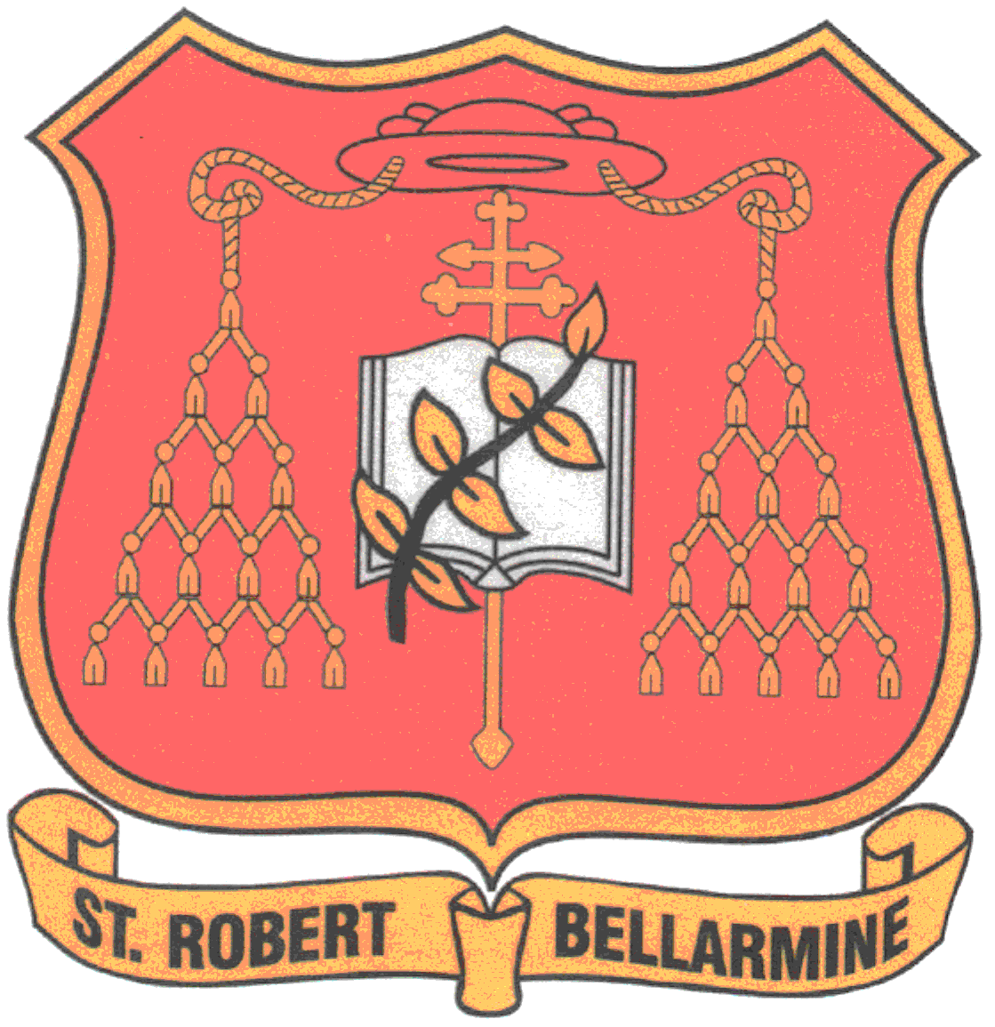

TACKLING EXTREMISM & RADICALISATION POLICY

Our Mission Statement

“We are God’s work of art.”

- Help each other
- Be happy
- Follow the light of Jesus
- Include everybody
- Everybody do their best in every way
- Be friends with everyone
- Be responsible for your own actions
- Be Respectful
- Work to the best of your abilities
- Parents, teachers and children support each other.

- POLICY STATEMENT
St Robert Bellarmine Catholic Primary School is fully committed to safeguarding and promoting the welfare of all its pupils. Every member of staff recognises that safeguarding against radicalisation and extremism is no different to safeguarding against any other vulnerability in today’s society. The Tackling Extremism and Radicalisation Policy sets out our beliefs, strategies and procedures to protect vulnerable individuals from being radicalised or exposed to extremist views by identifying who they are and promptly providing them with support.

- LINKS TO OTHER POLICIES
The Tackling Extremism and Radicalisation Policy links to the following policies:
- Child Protection and Safeguarding
- Equality Policy
- Anti-bullying Policy
- Positive Behaviour Management Policy
- E-Safety Policy
The following national guidelines should also be read when working with this policy:
- PREVENT Strategy HM Government
- Keeping Children Safe in Education DfE 2015
- Working together to Safeguard Children HM Government 2013

- AIMS AND PRINCIPLES
The Tackling Extremism and Radicalisation Policy is intended to provide a framework for dealing with issues relating to vulnerability, radicalisation and exposure to extreme views. We recognise that we are well placed to be able to identify safeguarding issues and this policy clearly sets out how the school will deal with such incidents and identifies how the curriculum and ethos underpins our actions.

The objectives are that:
- All governors, teachers, teaching assistants and non-teaching staff will have an understanding of what radicalisation and extremism are and why we need to be vigilant in school.
- All governors, teachers, teaching assistants and non-teaching staff will know what the school policy is on tackling extremism and radicalisation and will follow the policy guidance swiftly when issues arise.
- All pupils will understand the dangers of radicalisation and exposure to extremist views; building resilience against these and knowing what to do if they experience them.
- All parents/carers and pupils will know that the school has policies in place to keep pupils safe from harm and that the school regularly reviews its systems to ensure they are appropriate and effective.

The main aims of this policy are to ensure that staff are fully engaged in being vigilant about radicalisation, that they overcome professional disbelief that such issues will not happen here and ensure that we work alongside other professional bodies and agencies to ensure that our pupils are safe from harm here.

- DEFINITIONS AND INDICATORS
Radicalisation is defined as the act or process of making a person more radical or favouring of extreme or fundamental changes in political, economic or social conditions, institutions or habits of the mind.

Extremism is defined as the holding of extreme political or religious views.

There are a number of behaviours which may indicate a child is at risk of being radicalised or exposed to extreme views. These include:
- Spending increasing time in the company of other suspected extremists.
- Changing their style of dress or personal appearance to accord with the group.
- Day-to-day behaviour becoming increasingly centred on an extremist ideology, group or cause.
- Loss of interest in other friends and activities not associated with the extremists ideology, group or cause.
- Possession of materials or symbols associated with an extremist cause.
- Attempts to recruit others to the group/cause.
- Communications with others that suggests identification with a group, cause or ideology.
- Using insulting or derogatory names for another group.
- Increase in prejudice-related incidents committed by that person – these may include;
- Physical or verbal assault
- Provocative behaviour
- Damage to property
- Derogatory name calling
- Possession of prejudice-related materials
- Prejudice related ridicule or name calling
- Inappropriate forms of address
- Refusal to co-operate
- Attempts to recruit to prejudice-related organisations
- Condoning or supporting violence towards others.

- PROCEDURES FOR REFERRALS
Although serious incidents involving radicalisation have not occurred at St Robert Bellarmine Primary to date, it is important for us to be constantly vigilant and remain fully informed about the issues which affect the local area, city and society in which we teach. Staff are reminded to suspend any “professional disbelief” that instances of radicalisation “could not happen here” and be “professionally inquisitive” where concerns arise, referring any concerns through the appropriate channels. (See appendix 1 – Dealing with referrals)

We believe that it is possible to intervene to protect people who are vulnerable. Early intervention is vital and staff must be aware of the established processes for front line professionals to refer concerns about individuals and/or groups. We must have the confidence to challenge, the confidence to intervene and ensure that we have strong safeguarding practices based on the most up-to-date guidance and best practice.

Designated Staff for Child Protection and Safeguarding and will deal swiftly with any referrals made by staff or with concerns reported to staff.

The Headteacher as Designated Safeguarding lead will discuss the most appropriate course of action on a case by case basis and will decide when a referral to external agencies is needed (See appendix 1 – Dealing with referrals)

As with any child protection referral, staff must be made aware that if they do not agree with a decision not to refer, they can make the referral themselves and will be given the contact details to do this via the safeguarding board in the staffroom.

A Risk Assessment has been completed which plans for actions and training to be completed. This will be reviewed annually.

The Office for Security & Counter Terrorism works to counter the threat from
terrorism and their work is detailed in the counter terrorism strategy CONTEST. This
strategy is based on four areas of work:
• Pursue - To stop terrorist attacks
• Prevent - To stop people becoming terrorists or supporting terrorism
• Protect - To strengthen our protection against a terrorist attack
• Prepare - To mitigate the impact of a terrorist attack
Primarily our work will be concerned with PREVENTION and is outlined more
specifically in the DCSF document ‘Learning together to be safe: A toolkit to help
schools contribute to the prevention of violent extremism.’
(http://dera.ioe.ac.uk/8396/1/DCSF-Learning%20Together_bkmk.pdf)
This policy should be read alongside the school’s Safeguarding, Equal Opportunities,
E‐Safety and Anti‐bullying policies and the Governments PREVENT strategy.
(https://www.gov.uk/government/uploads/system/uploads/attachment_data/file/979
76/prevent-strategy-review.pdf)

- GOVERNORS, LEADERS AND STAFF
The Headteacher and the Deputy Designated Member of staff, Alex Davies, are the leaders for referrals relating to extremism and radicalisation. In the unlikely event that no SLT members and the Head teacher are not available, all staff know the channels by which to make referrals via the safeguarding board in the staffroom.

Staff will be fully briefed about what to do if they are concerned about the possibility of radicalisation relating to a pupil, or if they need to discuss specific children whom they consider to be vulnerable to radicalisation or extremist views.

The Headteacher will consult with external agencies to decide the best course of action to address concerns when they arise.

Prejudicial behaviour can be a factor in radicalisation and extremism. With this in mind, school has updated procedures for dealing with prejudicial behaviour, as outlined in the Behaviour Policy and Equality Policy.

- THE ROLE OF THE CURRICULUM
Our curriculum is broad and balanced. It promotes respect, tolerance and diversity. Children are encouraged to share their views and recognise that they are entitled to have their own different beliefs which should not be used to influence others.

Our PSHE provision is embedded across the curriculum including in religious, spiritual and moral education. It directs our assemblies and underpins the ethos of the school. It is recognised that children with low aspirations are more vulnerable to radicalisation and therefore we strive to equip our pupils with confidence, self-belief, respect and tolerance as well as setting high standards and expectations for themselves.

Children are regularly taught about how to stay safe when using the internet and are encouraged to recognise that people are not always who they say they are online. They are taught to seek adult help if they are upset or concerned about anything they read or see on the internet.

- STAFF TRAINING
Through INSET opportunities in school, we will ensure that our staff are fully aware of the threats, risks and vulnerabilities that are linked to radicalisation, are aware of the process of radicalisation and how this might be identified early on and are aware of how we can provide support as a school to ensure that our children are resilient and able to resist involvement in radical or extreme activities. See appendix 2

- VISITORS AND THE USE OF SCHOOL PREMISES
If any member of staff wishes to invite a visitor in the school, they must first seek agreement from the headteacher so that the visitor can enter school and then they will be subject to Safeguarding Checks including DBS checks and photo identification. Children are NEVER left unsupervised with external visitors regardless of safeguarding check outcomes.

Upon arriving at school, all visitors will read the child protection and safeguarding guidance and be made aware of who the DSLs are and how to report any concerns which they may experience.

If any agreement is made to allow non-school groups or organisations to use the premises, appropriate checks will be made before agreeing the contract. Usage will be monitored and in the event of any behaviour not in keeping with the Tackling Extremism and Radicalisation Policy, the school will contact the police and terminate the contract.

- ADDITIONAL MATERIALS
See Appendix 3 for further reading

- POLICY REVIEW
The St Robert Bellarmine Catholic Primary School Tackling Extremism and Radicalisation Policy will be reviewed regularly as part of the overall Child Protection and Safeguarding policy review.

This Policy will be adopted by the Governing Body in Feb 2018.

Signed…………………………………………………………….. Chair of Governors

Date………………………………

